**Lab sheet 9 - Document Clustering**

Kavishka Gamage – 17000475

**Term Similarity**

**Hamming distance**

Elephant term gives error when finding text similarity with believe

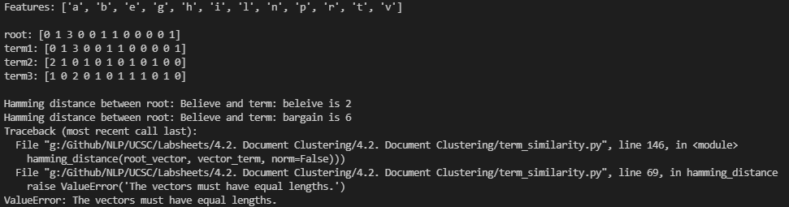

**Manhattan distance**

This measure also gave an error when terms don’t have equal length

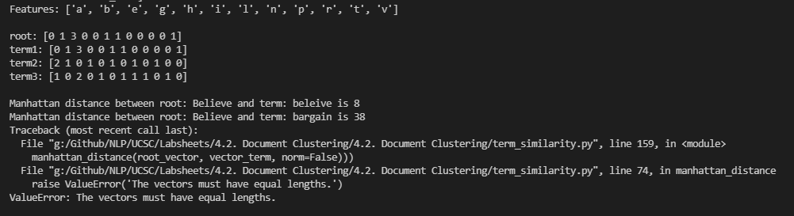

**Euclidian distance**

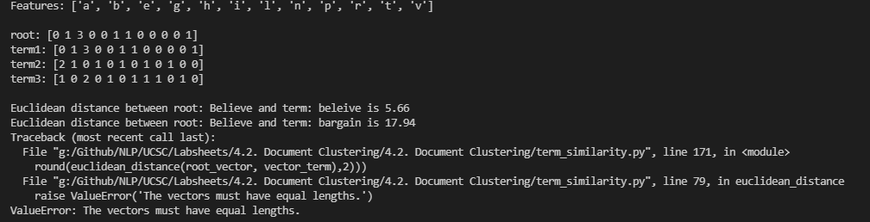

**Levenshtein edit distance**

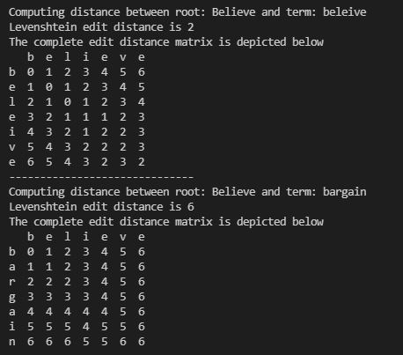

**Cosine similarity**

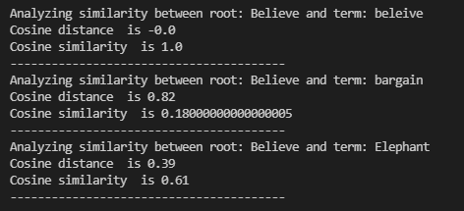

**Document Similarity**

Cosine similarity

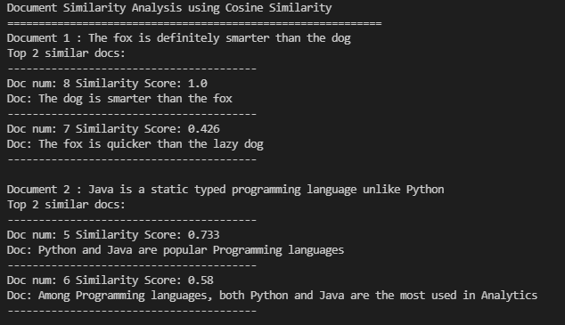

**Hellinger-Bhattacharya distance**

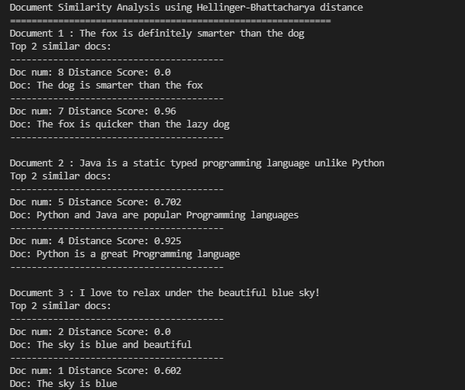

**BM25**

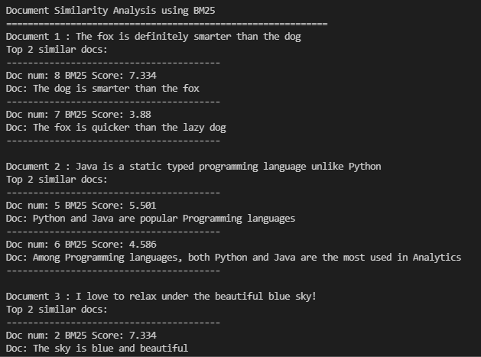

**Document Clustering**

**K-means**

Cluster details

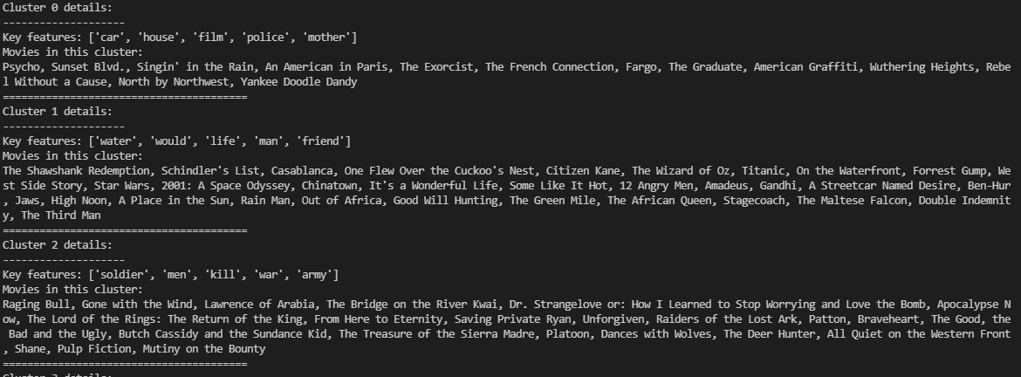

Cluster visualization

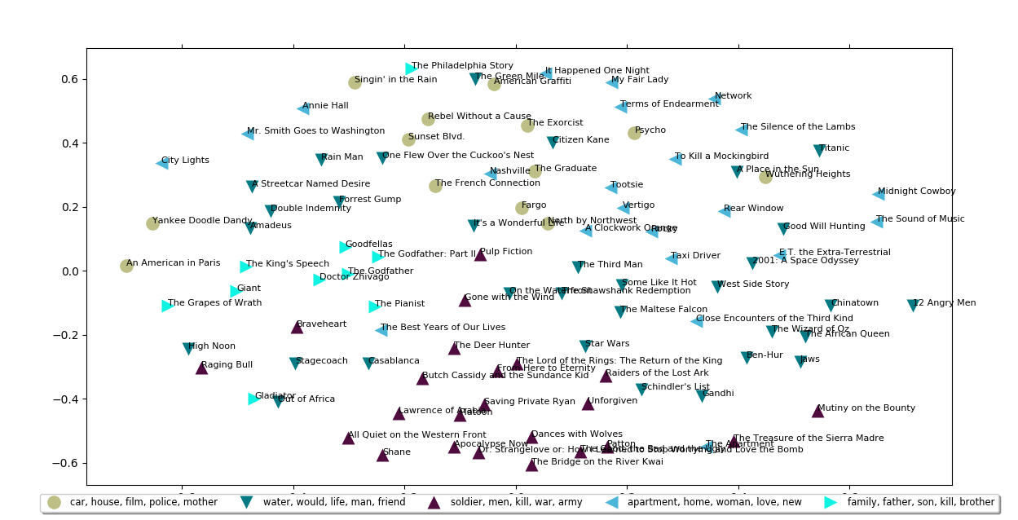

**Affinity Propagation**

**Cluster details**

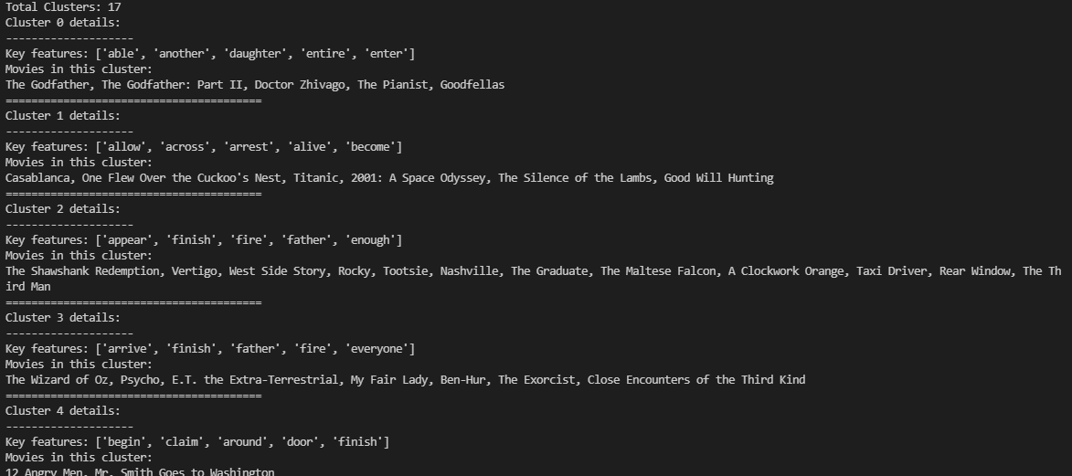

**Cluster visualization**

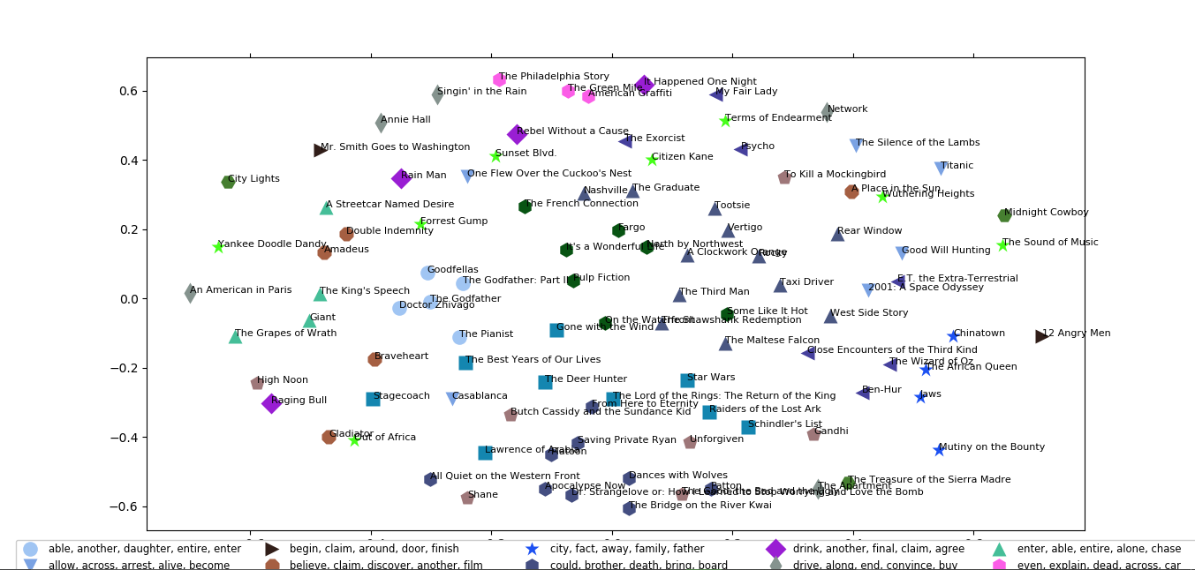

**Hierarchical clustering**

**Dendrogram**

